Real-Time Anxiety Detection Using Emotion Echo: A Multi-Modal and Embedded Approach
Dipanjan Saha¹, Ms. Swagata Kundu², Ishika Rana³, Meenakshi Sharma⁴ and Anjali Kumari⁵
1,2,3,4,5 Department of Information Technology, B. P. Poddar Institute of Management and Technology, 137, VIP Rd, Mali Bagan, Poddar Vihar, Rajarhat,
Kolkata, West Bengal 700052, India
dipanjansaha2003@gmail.com, swagata.kundu@bppimt.ac.in, ishikaishaan12@gmail.com, meenasharma282003@gmail.com, anjalikri2003ak@gmail.com
Abstract.
Anxiety disorders are among the most prevalent mental health conditions which is often remaining undiagnosed due to limited awareness and insufficient real-time diagnostic tools. Existing solutions are constrained by single-source data reliance, classifier inconsistencies, and inadequate responsiveness in real-world applications. In our work, we propose Emotion Echo, a multi-modal system designed for real-time anxiety detection. The system integrates facial emotion recognition using a custom convolutional neural network (CNN), physiological monitoring through a MAX30102 heart rate sensor, and psychological assessment via standardized questionnaires. These modalities are synthesized into a unified anxiety score using a weighted algorithm. Our approach achieves 82% accuracy in emotion classification and demonstrates superior performance over transformer-based models in terms of diagnostic precision and computational efficiency. Emotion Echo is optimized for deployment on mobile and embedded platforms, enabling accessible and scalable mental health monitoring. Future enhancements include adaptive reinforcement learning for personalized interventions and integration with clinical support systems.
Keywords: Anxiety Detection · Emotion Recognition · Multi-modal System · Deep Learning · Mental Health Monitoring
- Introduction
Depression and anxiety are among the most prevalent mental health disorders globally, affecting individuals across all age groups. Rising academic, professional, and social pressures have contributed to increasing psychological distress, particularly among younger populations. Despite their widespread occurrence, anxiety-related conditions often go undiagnosed and untreated due to societal stigma, limited mental health literacy, and lack of real-time diagnostic tools. Prolonged psychological stress impairs emotional well-being and is associated with reduced cognitive performance, lower productivity, physical health issues, and increased suicide risk.
Conventional diagnostic methodologies, such as psychometric questionnaires and structured clinical interviews, offer valuable insights but are inherently static, episodic, and reliant on subjective self-reporting. These approaches are not designed to capture real-time emotional fluctuations or support timely interventions. While machine learning (ML) and artificial intelligence (AI) have shown promise in mental health applications, existing systems often suffer from issues like reliance on unimodal data sources, inconsistent classifier performance, and limited real-time capability.
We propose Emotion Echo, a lightweight, multi-modal system for continuous anxiety detection to address these challenges. The framework integrates facial emotion recognition using a custom Convolutional Neural Network (CNN), real-time physiological monitoring via a MAX30102 heart rate sensor, and psychological evaluation through a standardized self-assessment questionnaire. Extracted features are combined using a weighted fusion algorithm to produce a composite anxiety score, enabling a more holistic and objective assessment of an individual’s mental state. Compared to transformer-based facial expression recognition (FER) models, Emotion Echo offers improved diagnostic accuracy, lower computational overhead, and greater adaptability for mobile and edge deployment. It presents a scalable, accessible solution for proactive mental health support.
- Objective
The primary objective of this study is to design and implement a real-time, multi-modal system for anxiety detection—Emotion Echo—that integrates facial expressions, physiological signals, and psychological self-assessments. The specific goals of this work are:
- To develop a lightweight and efficient facial emotion recognition (FER) model using a custom CNN, optimized for real-time use on edge devices.
- To capture real-time physiological data, specifically heart rate, using the MAX30102 sensor and incorporate it into the emotional analysis pipeline.
- To quantify psychological state through standardized behavioral questionnaires and translate responses into measurable depression/anxiety indicators.
- To fuse the three modalities—emotion score, heart rate, and questionnaire score—into a single composite anxiety score using a weighted scoring algorithm.
- To demonstrate how this fusion enhances diagnostic accuracy, personalization, and real-world applicability over unimodal approaches.
- Related work
Recent years have seen a significant rise in research on machine learning (ML)-based mental health monitoring systems, driven by the need for early and objective diagnosis of anxiety and depression. Priyaa et al. ^{[1]} demonstrated the effectiveness of using classical ML algorithms such as Random Forest and Naïve Bayes on DASS-21 responses for the prediction of stress-related conditions. Coutts et al. ^{[2]} employed wearable-based heart rate variability (HRV) and deep learning models to forecast mental health outcomes with notable accuracy. Ashok et al. ^{[3]} and Gedam and Paul ^{[14]} explored biosignal data - specifically electrodermal activity (EDA), blood volume pulse (BVP), and EEG - for stress and anxiety classification using ensemble methods like SVM and Random Forests.
Kumbhar et al. ^{[4]} introduced AnxoRelief, an ML-driven mobile application that incorporates standardized psychiatric scales (e.g., PHQ-9, GAD-7) and conversational AI, reporting high accuracy using Random Forest classifiers. In parallel, Ahmed et al. ^{[7]} and Gruda and Hasan ^{[16]} investigated the use of social media and online behavioral data for mental health prediction. These studies utilized regression and classification models to extract emotion-related features from user-generated content, revealing meaningful links between online expression and internal psychological states.
Bhatnagar et al. ^{[11]} and Ahmed et al. ^{[10]} applied CNN and Random Forest models to university and adolescent populations, achieving high accuracy (up to 96.8%) in identifying anxiety and depression, especially when incorporating sociodemographic and behavioral inputs. Moreover, Panicker and Gayathri ^{[17]} provided a survey of physiology-based stress detection, noting that multimodal integration - combining ECG, EMG, and EEG - enhances diagnostic robustness.
While these approaches provide valuable insights, many are constrained by limitations such as classifier inconsistency, reliance on unimodal data, or lack of real-time performance. The need for non-invasive, scalable, and real-time systems has been emphasized in multiple reviews ^{[17, 18]}, particularly for applications beyond clinical settings.
Emotion Echo addresses these gaps by employing a lightweight, real-time multi-modal architecture that combines facial emotion recognition via a custom CNN, heart rate monitoring using the MAX30102 sensor, and depression assessment through standardized self-report questionnaires. The system synthesizes these inputs into a unified anxiety score, offering enhanced diagnostic accuracy and user adaptability. Unlike transformer-based FER models that rely solely on visual cues, Emotion Echo incorporates physiological and psychological dimensions, ensuring a more comprehensive and context-aware mental health evaluation.
- Proposed System Model
Emotion Echo employs a three-stream data pipeline for comprehensive anxiety assessment:
- Facial Emotion Recognition (FER): Live video feed from a webcam is processed using a custom CNN model. The model classifies facial expressions into one of seven emotional categories. These classifications are converted into a normalized emotion score that reflects the user's emotional intensity over time.
- Heart Rate Monitoring: A MAX30102 pulse oximeter sensor continuously records heart rate (BPM). The heart rate is normalized to generate a physiological stress score, capturing the user's current arousal or rest state.
- Psychological Questionnaire: The user answers a set of clinically standardized questions from the Handbook of Psychiatric Rating Scales. Based on the responses, a depression score is computed and categorized (e.g., mild, moderate).
These three scores—emotion, physiological, and psychological—are fused using a weighted formula:
Anxiety Score=α⋅Emotion Score+β⋅Heart Rate Score+γ⋅Depression Score
Currently, the weights are set to:
α = 0.3 (emotional contribution), β = 0.3 (physiological contribution), γ = 0.4 (psychological contribution).
These weights reflect the importance of each modality and are designed to balance real-time emotional fluctuation with underlying psychological and physiological states.
Enhancement Over Unimodal Systems:
Unlike traditional systems that rely solely on facial cues or questionnaire responses, Emotion Echo integrates real-time affective, physiological, and cognitive signals, providing:
- Improved diagnostic precision by reducing reliance on any single data source.
- Personalization, as physiological and psychological baselines differ among individuals.
- Context-aware scoring, which can better reflect short-term stress spikes or long-term emotional patterns.
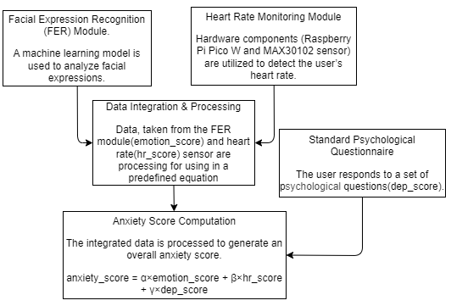
Figure 1: Block Diagram of Emotion Echo
- Proposed Technique
In this section, we present our proposed technique that introduces a Machine learning based multimodal real-time system for anxiety detection, focusing on:
- Real-time image processing with lightweight computation
- Real-time physiological data using hardware
- Psychological analysis by giving standard psychological questionnaires
  - Emotion Detection and Classification using FER
This module leverages a custom-built CNN to detect, classify, and quantify human emotions from facial expressions in real-time, using webcam feeds. It combines image preprocessing, emotion classification, and continuous mood tracking for dynamic emotional analysis
    - Emotion Detection from FER
The proposed technique aims to perform real-time emotion recognition from facial expressions using a custom-designed Convolutional Neural Network (CNN). The system workflow is divided into three primary stages: image preprocessing, emotion classification, and real-time deployment.
- Image Preprocessing: Facial expression images are converted to grayscale, normalized, and resized to 48×48×1 pixels to reduce computational complexity and ensure uniform input for the model.
- Emotion Classification: The proposed CNN consists of four convolutional layers (128, 256, 512, 512) with max-pooling and dropout layers for feature extraction and regularization. A softmax layer classifies expressions into 7 categories: Happy, Sad, Angry, Fearful, Surprised, Disgusted, and Neutral.
- Real-Time Deployment: The trained model is integrated into a webcam-based system using a Haar Cascade Classifier for face detection. Detected faces are pre-processed and passed to the CNN for real-time emotion prediction.
Customizations in Our CNN Model:
- Built from Scratch: Unlike pre-trained models, our CNN is designed specifically for facial emotion recognition, enabling better control over layer structure and performance optimization for real-time use.
- Progressive Convolution Layers: We use four Conv2D layers with increasing filter sizes (128 → 512), allowing effective extraction of both low- and high-level emotional features.
- High Dropout Regularization: A consistent dropout rate of 0.4 is applied after each convolution and dense layer to reduce overfitting, especially important with the FER2013 dataset.
- Lightweight Grayscale Input: Input images are resized to 48×48 and converted to grayscale, minimizing computational load and making the model ideal for mobile or embedded deployment.
- Deep Yet Efficient Dense Layers: Two dense layers (512 and 256 units) improve learning capacity without excessive complexity, ensuring high accuracy while maintaining fast inference speed.
    - Emotion Classification and Calculation
This module detects and quantifies emotions from live webcam feeds using a built-in CNN model.
- Detected emotion is scored based on its intensity and psychological impact.
- The system records and aggregates emotion scores every 30 seconds to track mood trends and trends.
- Emotional scoring can help identify patterns of emotional distress and help describe levels of dissatisfaction in the system.
  - Heart Rate Detection and Cloud Integration
This module implements real-time heart rate monitoring using a MAX30102 heart rate sensor connected to a Raspberry Pi Pico W, with cloud integration via Firebase for continuous health monitoring. The sensor detects heartbeats, estimates BPM, and sends data online for analysis as part of an anxiety assessment system.
- The MAX30102 sensor connected to the analog stick receives the pulse signals, which are processed to estimate the BPM using a simple formula (BPM = value / 120).
- OLED display (128×64) connected via I2C (pins 0: SDA, 1: SCL) provides real-time visualization of BPM.
- The Raspberry Pi Pico W connects to WiFi using predefined credentials, allowing timestamped BPM data to be sent to Firebase via HTTP POST.
- The system operates in a continuous loop for live monitoring, uploading and displaying data, and has interrupt control for safe reset the device if needed.
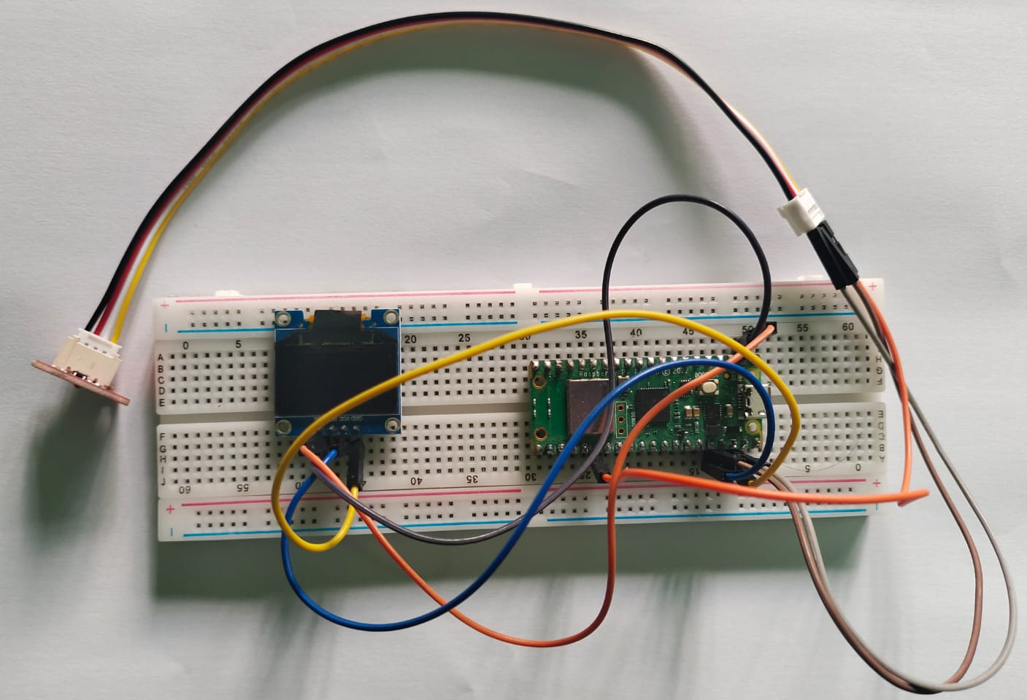
Figure 2:
  - Depression Score Calculation
The system includes a self-assessment module to evaluate depression levels using a structured questionnaire from the Handbook of Psychiatric Rating Scales^{[18]}.
- Users answer a standardized questionnaire, with each response assigned a predefined score.
- The total score classifies depression into Minimal (0–9), Mild (10–18), Moderate (19–29), or Severe (30+) categories.
- A web-based interface records responses instantly, providing immediate feedback.
- The depression score contributes to anxiety level calculations in the system.
  - Proposed Algorithm
Step 1: Import Libraries  1.1 Import keras, cv2, numpy, time, network, urequests, etc.  Step 2: Train & Save CNN Model  2.1 Load image data → preprocess (grayscale, reshape, normalize).  2.2 Encode labels → one-hot format.  2.3 Build CNN: Conv2D + ReLU + MaxPooling + Dropout → Dense → Softmax.  2.4 Compile with Adam; train (128 batch, 100 epochs).  2.5 Save model architecture (.json) and weights (.h5).  Step 3: Real-Time Emotion Detection  3.1 Load model & Haar cascade face detector.  3.2 Capture video for 30s → detect face → predict emotion.  3.3 Map emotions to scores → calculate average emotion_score. | Step 4: Heart Rate Detection  4.1 Connect to WiFi → initialize OLED & pulse sensor.  4.2 Read ADC value → estimate heart_rate = value / 120.  4.3 Display & upload BPM to Firebase.  Step 5: Depression Score Assessment  5.1 Display 10 behavioral questions.  5.2 On submission → calculate total_score.  5.3 Classify:  ≤9: Minimal, 10–18: Mild, 19–29: Moderate, ≥30: Severe.  Step 6: Anxiety Score Calculation  6.1 Input: emotion_score, heart_rate, depression_level.  6.2 Normalize: hr_score = (heart_rate - 60)/100, dep_score = depression_level / 30  6.3 Compute: anxiety_score = α×emotion_score + β×hr_score + γ×dep_score  6.4 Display anxiety_score.
  - Complexity of The Algorithm
The proposed system balances performance and accuracy by combining deep learning with real-time processing. While the CNN training phase has high time complexity due to large datasets and deep layers, the inference, heart rate detection, and scoring components operate in constant time. This ensures efficient execution, making the system suitable for real-time mental health monitoring.
Component | Time Complexity | Space Complexity
CNN Training | O(n × filters × kernel² × epochs) | O(n × image size + m)
Emotion Detection | O(t × (f² + k × model)) | O(f² + m)
Heart Rate Detection | O(1) | O(1)
Depression Score | O(1) | O(1)
Anxiety Score | O(1) | O(1)
  - Scoring Weight Rationale
The anxiety score in our system is computed using a weighted sum of three normalized components: emotion score (α), heart rate score (β), and depression score (γ). These weights—α = 0.3, β = 0.3, and γ = 0.4—were selected through empirical testing. We followed a data-driven, trial-and-error approach:
- First, a range of normalized values was collected for each score across multiple users. Then, different combinations of α, β, and γ were tested to calculate the final anxiety score.
- These values were compared against known participant behaviors and psychological states to observe which weight set yielded outputs most aligned with reality.
- The combination of α = 0.3, β = 0.3, γ = 0.4 consistently produced anxiety scores that matched user-reported experiences and domain expectations.
The psychological questionnaire is given the highest weight (γ = 0.4) because it reflects the user's underlying mental state over time, unlike facial expressions or heart rate which can fluctuate momentarily. These questions are based on clinically validated psychiatric scales, making them a more reliable indicator of anxiety severity. By prioritizing the questionnaire, the system ensures that chronic or consistent symptoms are not overshadowed by temporary emotional or physiological changes, resulting in a more balanced and accurate anxiety assessment.
- Result and Analysis: In this section, we will discuss, experimental setup, simulation results and comparative analysis of different approaches
  - Experimental Set up
The Emotion Echo system was evaluated using real-time data from multiple participants, including facial expressions, heart rate measurements, and responses to a standardized psychological questionnaire. For emotion recognition, a custom CNN model was trained on the FER2013 dataset from Kaggle^{[19]}, which contains over 35,000 labeled facial images. The dataset was split 80% for training and 20% for validation/testing. Participants were selected to represent diverse behavioral and physiological profiles. The final anxiety score was calculated using normalized values and weighted fusion: α = 0.3 (emotion), β = 0.3 (heart rate), and γ = 0.4 (questionnaire), ensuring accurate and personalized detection.
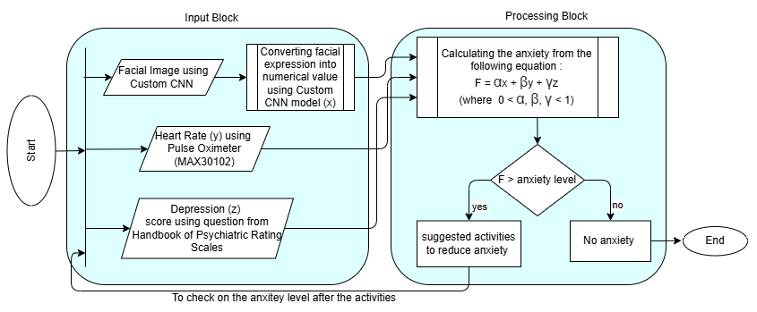
Figure 3: Flow Chart of Emotion Echo
  - Rationale for choosing Custom CNN Model
Emotion detection requires a balance between accuracy, speed, and efficiency. Among the five models tested—Basic CNN, EfficientNet-B0, VGG16, MobileNetV2, and our Custom CNN—the Custom CNN proved to be the most effective. Unlike pre-trained models, it’s trained from scratch to learn emotion-specific features, offering high accuracy (82%) with faster inference and lower computational cost. While VGG16 and EfficientNet-B0 are accurate but heavy, and MobileNetV2 is efficient but slightly less accurate, our model strikes the best balance for real-time use. Its optimized size and performance make it ideal for deployment across devices, including edge and mobile platforms.
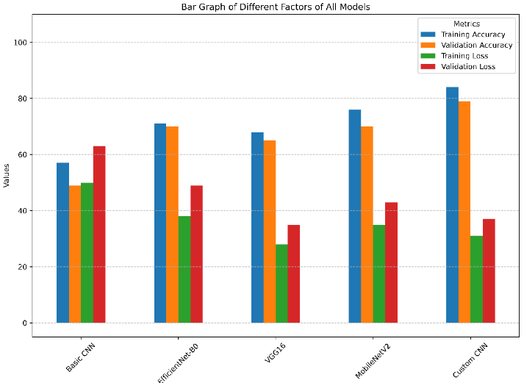
Figure 4: Comparison Graph between Different Models
  - Evaluation Metric
To evaluate the effectiveness of the facial emotion recognition component, we analyzed classification performance on the FER2013 dataset using standard metrics. The results are summarized in below table.
Emotion | Precision | Recall | F1-Score
Happy | 0.85 | 0.88 | 0.86
Sad | 0.81 | 0.78 | 0.79
Angry | 0.80 | 0.76 | 0.78
Fearful | 0.76 | 0.74 | 0.75
Surprised | 0.84 | 0.87 | 0.85
Disgusted | 0.72 | 0.70 | 0.71
Neutral | 0.79 | 0.82 | 0.80
Average | 0.79 | 0.79 | 0.79
The confusion matrix shows that the Custom CNN model performs well across all emotion classes, with the highest accuracy in detecting Happy and Surprised emotions, while minor misclassifications occur between similar expressions like Sad–Neutral and Angry–Fearful.
Actual \ Predicted | Happy | Sad | Angry | Fearful | Surprised | Disgusted | Neutral
Happy | 135 | 4 | 1 | 2 | 6 | 0 | 2
Sad | 3 | 125 | 5 | 6 | 2 | 3 | 6
Angry | 1 | 6 | 123 | 7 | 1 | 7 | 5
Fearful | 2 | 5 | 6 | 118 | 4 | 4 | 2
Surprised | 5 | 1 | 2 | 2 | 134 | 2 | 4
Disgusted | 0 | 2 | 5 | 3 | 1 | 115 | 4
Neutral | 2 | 4 | 3 | 2 | 5 | 4 | 130
  - Simulation Results
To ensure the authenticity of the test results, we have selected individuals from diverse backgrounds, attitudes, and personalities. This variation allows us to capture a broad spectrum of emotional and psychological states, ensuring that the data is representative and comprehensive.
UID | Emotion Score | Heart Rate Score | Depression Score | Anxiety Score
U1 | 0.78 | 0.65 | 0.50 (15/30) | 0.629
U2 | 0.53 | 0.62 | 0.23 (7/30) | 0.437
U3 | 0.82 | 0.72 | 0.30 (9/30) | 0.582
U4 | 0.92 | 0.84 | 0.83 (25/30) | 0.860
U5 | 0.75 | 0.68 | 0.86 (26/30) | 0.773
U6 | 0.71 | 0.62 | 0.60 (18/30) | 0.639
U7 | 0.24 | 0.54 | 0.76 (23/30) | 0.538
U8 | 0.79 | 0.70 | 0.40 (12/30) | 0.607
U9 | 0.64 | 0.63 | 0.63 (19/30) | 0.633
U10 | 0.78 | 0.86 | 0.73 (22/30) | 0.789
U11 | 0.38 | 0.61 | 0.20 (6/30) | 0.377
U12 | 0.61 | 0.74 | 0.36 (11/30) | 0.549
U13 | 0.89 | 0.82 | 0.90 (27/30) | 0.873
U14 | 0.74 | 0.75 | 0.70 (21/30) | 0.727
U15 | 0.83 | 0.78 | 0.56 (17/30) | 0.707
Based on the result matrix from 15 diverse participants, the Emotion Echo system demonstrates consistent and realistic anxiety scoring across varying emotional, physiological, and behavioral profiles. Users with higher depression scores consistently yielded higher overall anxiety scores, even when emotion or heart rate scores were moderate. This supports the decision to assign greater weight (γ = 0.4) to the psychological questionnaire, as it captures underlying mental health conditions more reliably than transient emotional or physiological fluctuations. The results confirm the effectiveness of our weighted multi-modal fusion approach for accurate and personalized anxiety detection.
  - Comparison with Benchmark Work
Transformer-based FER models use static facial expressions to infer mental health, relying on architectures like Swin or Vision Transformers. However, facial cues can be masked or culturally influenced, making them unreliable for detecting complex conditions like anxiety. This risks misinterpretation and offers a limited view of mental well-being.
In contrast, our model uses a multi-modal approach, combining facial analysis (Custom CNN), real-time heart rate, and behavioral questionnaires, to capture emotional, physiological, and cognitive factors. It delivers real-time, personalized anxiety scores with greater clinical relevance than static, image-based models.
Both the existing Transformer-based FER model and our Custom CNN model use the same FER2013 dataset for emotion classification. However, the accuracy of our model consistently falls in the higher range (74–82%), while their model generally ranges between 70–75%. This difference, though seemingly small, is significant in the context of multi-class emotion classification and especially relevant when these predictions are used for downstream mental health inference.
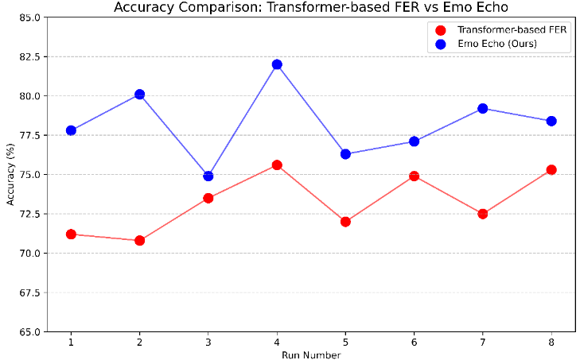
Figure 5: Accuracy Comparison Between TFER and Emo Echo
Our model significantly outperforms the existing Transformer-based FER system by incorporating a multi-modal approach instead of relying solely on facial expressions. While their model uses only image-based emotion classification, we combine facial analysis (via a Custom CNN), heart rate monitoring, and behavioral questionnaire scores. This integration captures not just visual cues, but also physiological and cognitive markers of anxiety, providing a more complete and accurate assessment. Moreover, our CNN is optimized for real-time, edge-level deployment, unlike their heavy Transformer models that are less practical for low-latency, real-world use.
- Conclusion
This paper presented Emotion Echo, a real-time, multi-modal system for anxiety detection and management. By integrating facial emotion recognition, physiological signals, and psychological assessments, the system offers a comprehensive and accurate evaluation of emotional states. Its lightweight and privacy-aware design supports both clinical and personal applications, with superior performance compared to conventional and transformer-based models.
Future work will focus on reinforcement learning for adaptive interventions, enhanced personalization via longitudinal data, and integration with wearable devices and conversational agents. In critical cases, the system aims to facilitate timely professional support through clinical collaboration. These developments aspire to deliver a scalable, intelligent, and user-centric solution for mental health support.

References
- Priya, Anu & Garg, Shruti & Tigga, Neha. (2020). Predicting Anxiety, Depression and Stress in Modern Life using Machine Learning Algorithms. Procedia Computer Science. 167. 1258-1267. 10.1016/j.procs.2020.03.442.
- Ashok, M., Regonda, N., Reddy, C.S., Prashanthi, P.: A method for detection for anxiety and depression of human brain using machine learning and artificial intelligence. Int. J. Adv. Sci. Technol. 29, 5939–5944 (2020).
- Kumbhar, Mursal & Aleem, Zonera & Rajput, Aisha & Narejo, Sanam & Rathi, Mahaveer. (2020). Detecting and Relieving anxiety on-the-go using Machine Learning Techniques. 10.13140/RG.2.2.11178.49609.
- Nath, R.K., Thapliyal, H. Machine Learning-Based Anxiety Detection in Older Adults Using Wristband Sensors and Context Feature. SN COMPUT. SCI. 2, 359 (2021). https://doi.org/10.1007/s42979-021-00744-z
- P. Bobade and M. Vani, "Stress Detection with Machine Learning and Deep Learning using Multimodal Physiological Data," 2020 Second International Conference on Inventive Research in Computing Applications (ICIRCA), Coimbatore, India, 2020, pp. 51-57, doi: 10.1109/ICIRCA48905.2020.9183244
- Ahmed, Arfan & Aziz, Sarah & Toro, Carla & Alzubaidi, Mahmood & Irshaidat, Sara & Abu Serhan, Hashem & Abd-alrazaq, Alaa & Househ, Mowafa. (2022). Machine Learning Models to Detect Anxiety and Depression through Social Media: A Scoping Review. Computer Methods and Programs in Biomedicine Update. 2. 100066. 10.1016/j.cmpbup.2022.100066..
- Zhang, Huijun & Feng, Ling & Li, Ningyun & Jin, Zhanyu & Cao, Lei. (2020). Video-Based Stress Detection through Deep Learning. Sensors. 20. 5552. 10.3390/s20195552..
- Razavi M, Ziyadidegan S, Mahmoudzadeh A, Kazeminasab S, Baharlouei E, Janfaza V, Jahromi R, Sasangohar F. Machine Learning, Deep Learning, and Data Preprocessing Techniques for Detecting, Predicting, and Monitoring Stress and Stress-Related Mental Disorders: Scoping Review. JMIR Ment Health. 2024 Aug 21;11:e53714. doi: 10.2196/53714. PMID: 39167782; PMCID: PMC11375388.
- Bota, P. (no date) “A Review, Current Challenges, and Future Possibilities on Emotion Recognition using Machine Learning and Physiological Signals,” IEEE Access. Institute of Electrical and Electronics Engineers (IEEE). doi: 10.1109/ACCESS.2019.2944001.
- Ahmed, A. (2020) “A Machine Learning Approach to detect Depression and Anxiety using Supervised Learning,” 2020 IEEE Asia-Pacific Conference on Computer Science and Data Engineering (CSDE). IEEE.
- Bhatnagar, S., Agarwal, J., Sharma, O.R.: Detection and classification of anxiety in university students through the application of machine learning. Amity University Uttar Pradesh & Graphic Era Deemed to be University, India.
- Tabares Tabares M, Vélez Álvarez C, Bernal Salcedo J, Murillo Rendón S. Anxiety in young people: Analysis from a machine learning model. Acta Psychol (Amst). 2024 Aug;248:104410. doi: 10.1016/j.actpsy.2024.104410. Epub 2024 Jul 20. PMID: 39032273.
- Gedam, Shruti & Paul, Sanchita. (2021). A Review on Mental Stress Detection Using Wearable Sensors and Machine Learning Techniques. IEEE Access. PP. 1-1. 10.1109/ACCESS.2021.3085502.
- Ancillon L, Elgendi M, Menon C. Machine Learning for Anxiety Detection Using Biosignals: A Review. Diagnostics (Basel). 2022 Jul 25;12(8):1794. doi: 10.3390/diagnostics12081794. PMID: 35892505; PMCID: PMC9332282.
- Gruda, Jon & Hasan, Souleiman. (2019). Feeling anxious? Perceiving anxiety in tweets using machine learning. 10.31234/osf.io/xfmqd.
- Panicker, Suja & Gayathri, Prakasam. (2019). A survey of machine learning techniques in physiology based mental stress detection systems. Biocybernetics and Biomedical Engineering. 39. 10.1016/j.bbe.2019.01.004.
- Hickey BA, Chalmers T, Newton P, Lin CT, Sibbritt D, McLachlan CS, Clifton-Bligh R, Morley J, Lal S. Smart Devices and Wearable Technologies to Detect and Monitor Mental Health Conditions and Stress: A Systematic Review. Sensors (Basel). 2021 May 16;21(10):3461. doi: 10.3390/s21103461. PMID: 34065620; PMCID: PMC8156923.
- Lyerly, S.B., Abbott, P.S.: Handbook of Psychiatric Rating Scales (1950–1964). Psychological Assessment Associates, National Institute of Mental Health.
- Sambare, M.: Facial Expression Recognition (FER2013). Available at: https://www.kaggle.com/datasets/msambare/fer2013

